UML Design Diagram(Fowchart, ERD, Use Case Diagram)

- FlowChart
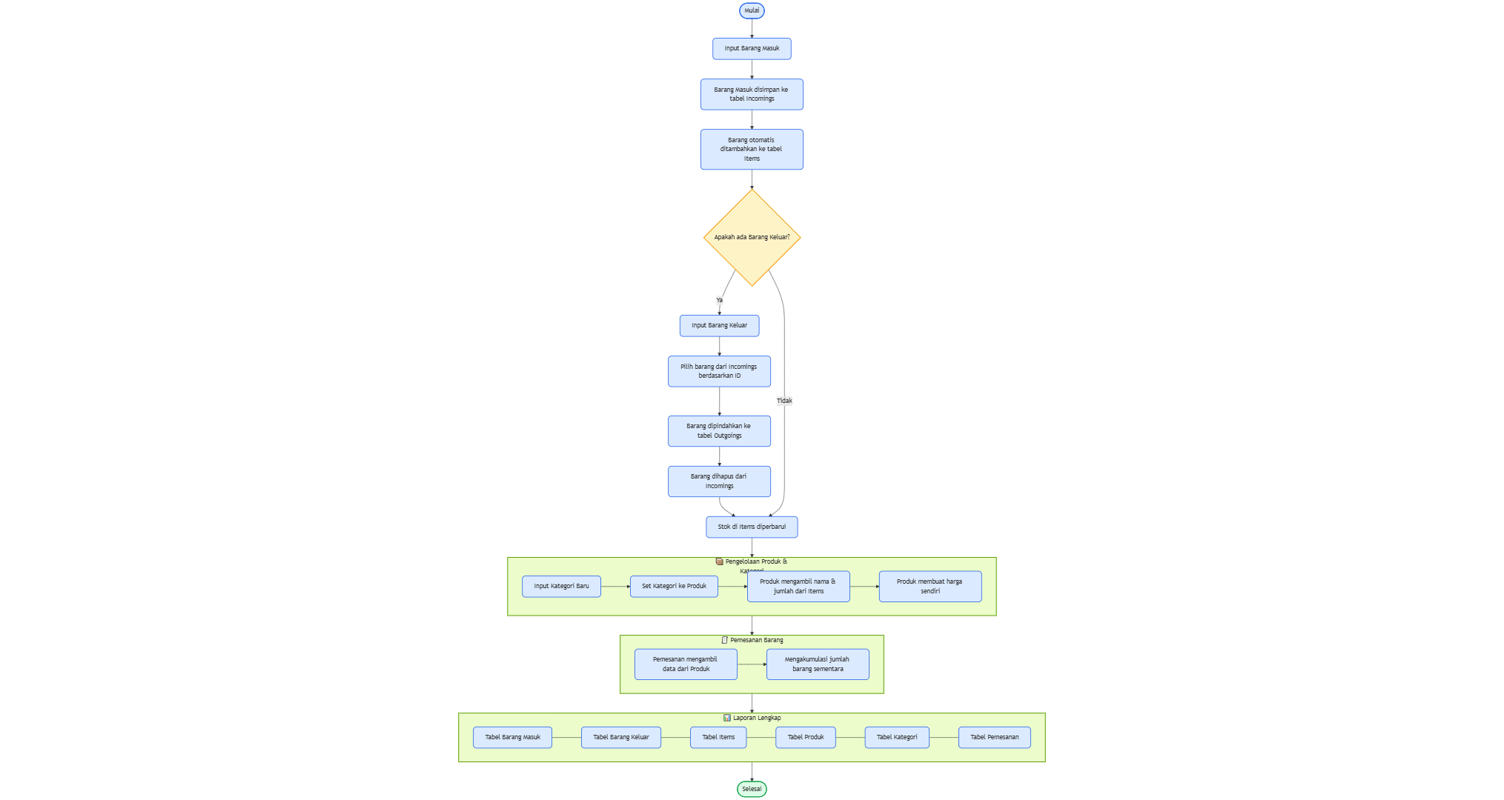
- ERD
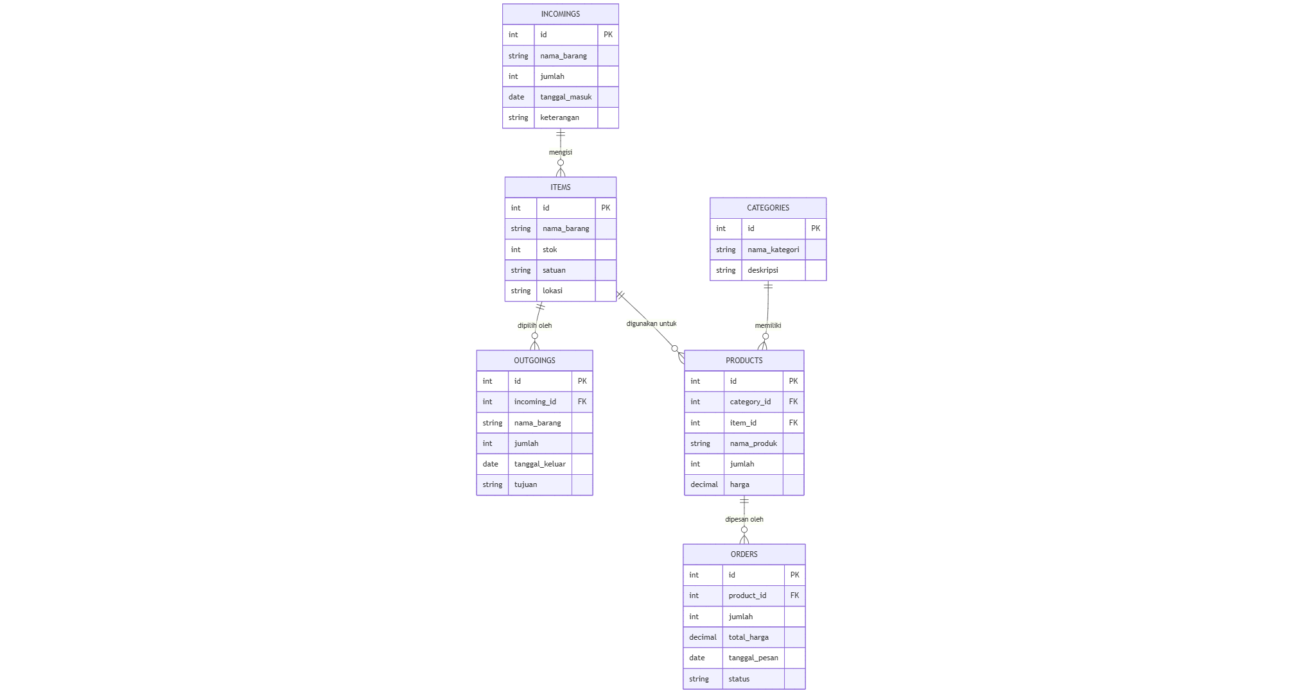
- Use Case Diagram
